threshold_vals = [0,25, 50, 75, 100, 125, 150]

acc = [84.13, 86.08, 88.83, 89.04, 87.55, 89.81, 90.21]

size = [2926, 2366, 1833, 1501, 1243, 1076, 967]

plt.plot(x, acc)

plt.title('Ensemble Classifier Accuracy at Different Threshold Values')

plt.xlabel('Threshold Value (kwH)')

plt.ylabel('Accuracy')

plt.show()

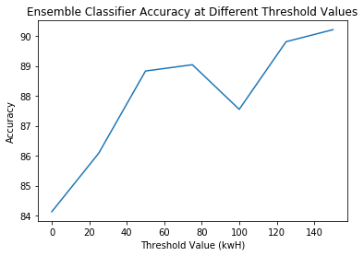

plt.plot(x, size)

plt.title('Dataset Size at Different Threshold Values')

plt.xlabel('Threshold Value (kwH)')

plt.ylabel('Size of Dataset')

plt.show()

